|  |  |  |  |
| --- | --- | --- | --- |
| **Name: ____________________**  **2nd Grade Week of October 22 – October 26**  Rm 4 | Sr. Tina | tdinh@stanthonygardena.org | | | |
| **What we’re learning this week:**  Religion: Saints  Math: 3-digit numbers; reach 26% completion for ST Math  Word Study: words with double consonants and ck  Reading: Ask and answer questions about key details in a story  Grammar/Writing: Types of Sentences Review, Saint Report | **Homework and Schedule** | | |
| **Directions:**  Assigned HW is completed by each student daily. Please return the Behavior Chart each day in the HW folder for daily recording. **Parents/guardians need to sign each day after all assignments are completed. Send this paper back at the end of the week along with completed work in the HW folder. The Behavior Chart will be collected Monday.** | | **Parent Initials** |
| **Monday** | * Math: pages 47, 48 * Read for at least 20 minutes and fill out reading log * Fluency: High Frequency Words Packet (1 page per day) * Word Work: Choose from Menu * Signed Behavior Chart |  |
| **Tuesday** | * Math: Chapter 2 Review/Test packet * Read for at least 20 minutes and fill out reading log * Fluency: High Frequency Words Packet (1 page per day) * Word Work: Choose from Menu * Signed Behavior Chart * Pack library books and Prayer booklet in backpack! |  |
| **Wednesday** | * **Library Books due!** * Math: Mock Chapter 2 Test (odd numbers) * Read for at least 20 minutes and fill out reading log * Fluency: High Frequency Words Packet (1 page per day) * Word Work: Choose from Menu * Signed Behavior Chart * Prepare PE uniforms for PE tomorrow! |  |
| **Thursday** | * **Word Work Quiz!** * Math: Mock Chapter 2 Test (even numbers) * Read for at least 20 minutes and fill out reading log * Fluency: High Frequency Words Packet (1 page per day) * Word Work: Choose from Menu * Signed Behavior Chart |  |
| **Friday** | * **School Mass!** * **HF Spelling Test!** * **Chapter 2 Math Test!** * Signed Behavior Chart due Monday! |  |

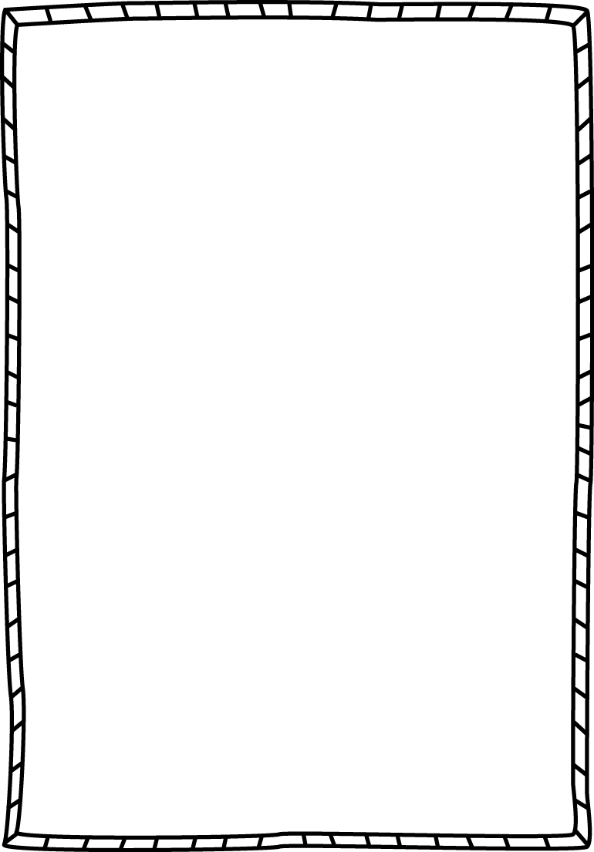**Word Work**

**Objective:** I can read, write, and sort words with **double consonants** and **ck.**

**Instructions:** To practice your pattern words, choose a different activity from your Word Work Homework Menu to complete each day.

|  |  |  |  |
| --- | --- | --- | --- |
| click | bitter | track | collect |
| happen | rabbit | traffic | channel |
| wedding | thick | assist | puppet |
| neck | stick | bossy | bottom |
| button | duck | hammock | backpack |
| shock | clock | lock | snack |

**Weekly Behavior Chart**

|  |  |  |
| --- | --- | --- |
| **Day** | **Today’s Color** | **Parent Initials** |
| Monday |  |  |
| Tuesday |  |  |
| Wednesday |  |  |
| Thursday |  |  |
| Friday |  |  |

**= green, blue, pink, or purple (Great day!!)**

**= yellow (I need to think about my choices, I can do better tomorrow)**

**= orange or red (Parents get notified, I can do better tomorrow!)**