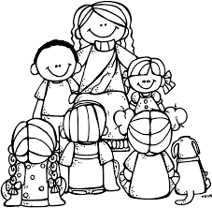
Name: ____________________

2nd Grade Week of November 19 – November 23
Rm 4 | Sr. Tina | tdinh@stanthonygardena.org

What we’re learning this week:  Religion: Greatest Commandment  Math: Review  Word Study: Review  Reading: Review  Grammar/Writing:  Prepositions and Verbs; How-to-Article | Homework and Schedule
 | Directions:  Assigned HW is completed by each student daily. Please return the Behavior Chart each day in the HW folder for daily recording. Parents/guardians need to sign each day after all assignments are completed. Send this paper back at the end of the week along with completed work in the HW folder. The Behavior Chart will be collected Monday. |  | Parent Initials
 | Monday | - Math: pages 73, 74  - Read for at least 20 minutes and fill out reading log  - Signed Behavior Chart
 | Tuesday | - Math: pages 75, 76  - Read for at least 20 minutes and fill out reading log
 | Wednesday | - School Mass!  - Friendsgiving! Noon Dismissal!  - Signed Behavior Chart
 | Thursday | - No School! Thanksgiving Break!
 | Friday | - No School! Thanksgiving Break!  - School starts again Tuesday, November 27th!
Weekly Behavior Chart

Day | Today’s Color | Parent Initials
Monday
Tuesday
Wednesday
Thursday |  | No school!
Friday |  | No school!

= green, blue, pink, or purple (Great day!!)

= yellow (I need to think about my choices, I can do better tomorrow)

= orange or red (Parents get notified, I can do better tomorrow!)

