|  |  |  |  |
| --- | --- | --- | --- |
| **Name: ____________________**  **2nd Grade Week of December 10-December 14**  Rm 4 | Sr. Tina | tdinh@stanthonygardena.org | | | |
| **What we’re learning this week:**  Religion: Commandments and Advent  Math: 2-digit addition with regrouping; reach 41% completion for ST Math by end of week.  Word Study: review open (cv) and closed (cvc) syllable words  Reading: Recount fables and folktales and identify main lesson of story.  Grammar/Writing:  Verbs; How-to-Article  Social Studies  Cultures | **Homework and Schedule** | | |
| **Directions:** Remember to write your name above and you’re your parent initial next to each day. The Behavior Chart will be collected this Friday before your Christmas Break! | | **Parent Initials** |
| **Monday** | * Math: Go Math pages 87, 88 (See Math Guide for help) * Reading: read for at least 20 minutes and fill out reading log * High Frequency Words Packet (1 page per day) * Signed Behavior Chart * **Parents sign Chapter 3 Math Test and return with necessary student corrections by December 12/14.** * Wrap a new reading book for our Christmas Exchange on Friday! No more than $5 in value! There is no need to write a name. |  |
| **Tuesday** | * **Christmas Sweater over your regular uniform Day!** * Math: Go Math pages 89-90 * Reading: read for at least 20 minutes and fill out reading log * High Frequency Words Packet (1 page per day) * Signed Behavior Chart * **Prepare Mass Uniforms for Mass tomorrow!** |  |
| **Wednesday** | * **School Mass!** * **Library Books Due!** * Math: Go Math pages 91, 92 * Read for at least 20 minutes and fill out reading log * High Frequency Words Packet (1 page per day) * Signed Behavior Chart * **NO PE Thursday! Christmas Show Rehearsal!** |  |
| **Thursday** | * Signed Behavior Chart * **No PE! Christmas Show rehearsal in the Church!** * **No Homework!** * **Christmas Show! Meet in classroom at 5:30pm in Room 4!** |  |
| **Friday** | * **School Mass!** * **Work Work Quiz!** * **HF Spelling Quiz!** * **Christmas Exchange!!** * **Noon Dismissal! Have a blessed Christmas Break! Class resumes on Thursday, Jan 3rd!** |  |

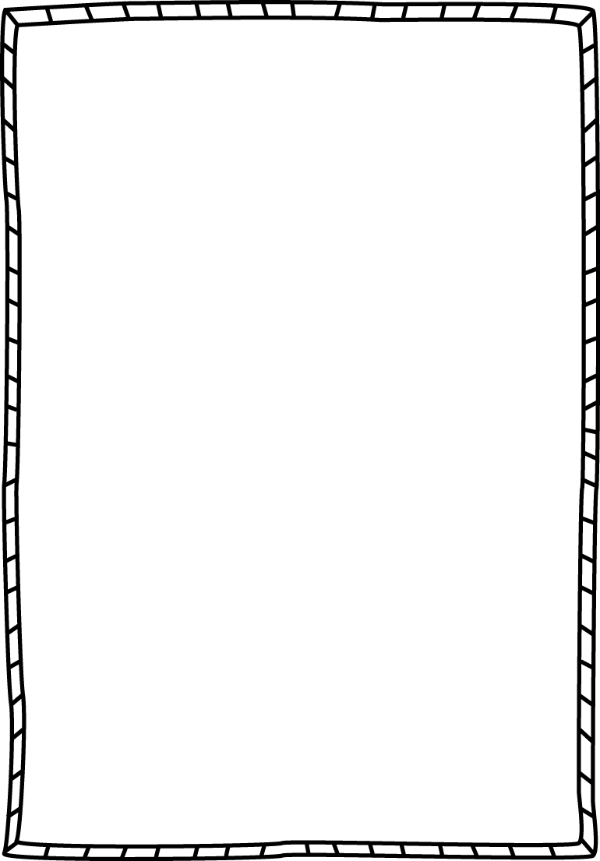**Word Work**

**Objective:** I can read, write, and sort open (cv) and closed (cvc) syllables.

**Rule:** Open syllables ends with a vowel where the vowel usually makes the long sound. Closed syllables ends with a consonant where the vowel usually makes the short sound.

**Instructions:** To practice your pattern words, choose a different activity from your Word Work Homework Menu to complete each day.

|  |  |  |  |
| --- | --- | --- | --- |
| she | he | hi | which |
| shut | no | bath | chest |
| chat | go | rest | we |
| crib | drop | so | yo-yo |
| robot | catnip | candle | chosen |
| unfit | music | label | hello |

**Weekly Behavior Chart**

|  |  |  |
| --- | --- | --- |
| **Day** | **Today’s Color** | **Parent Initials** |
| Monday |  |  |
| Tuesday |  |  |
| Wednesday |  |  |
| Thursday |  |  |
| Friday |  |  |

**= green, blue, pink, or purple (Great day!!)**

**= yellow (I need to think about my choices, I can do better tomorrow)**

**= orange or red (Parents get notified, I can do better tomorrow!)**