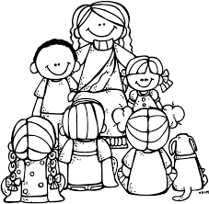
Name: ____________________

2nd Grade Week of December 31-January 4
Rm 4 | Sr. Tina | tdinh@stanthonygardena.org

What we’re learning this week:  Religion: Commandments  Math: 2-digit addition with regrouping; reach 42% completion for ST Math by end of week.  Word Study: review open (cv) and closed (cvc) syllable words  Reading: Review recounting fables and folktales and identify main lesson of story.  Grammar:  Proper Nouns | Homework and Schedule
 | Directions: Remember to write your name above and have your parent initial next to each day. The Behavior Chart will be collected on Monday. |  | Parent Initials
 | Monday | - No School! Christmas Break!
 | Tuesday | - No School! Christmas Break!
 | Wednesday | - No School! Christmas Break!
 | Thursday | - Welcome Back from Break!  - Math: Go Math pages 93-94  - Read for at least 20 minutes and fill out reading log  - High Frequency Packet  - Signed Behavior Chart
 | Friday | - School Mass!

Weekly Behavior Chart

Day | Today’s Color | Parent Initials
Monday
Tuesday
Wednesday
Thursday
Friday

= green, blue, pink, or purple (Great day!!)

= yellow (I need to think about my choices, I can do better tomorrow)

= orange or red (Parents get notified, I can do better tomorrow!)

