Third Grade Life Cycle Project

In class we have discussed the life cycle of plants and animals, from strawberries to crocodiles. Now it is your chance to do some research about your favorite plant or animal!
DUE IN CLASS ON THURSDAY 1/25

Project
Let’s get growing! Design a poster board describing the life cycle of a plant or animal that you are interested in. Try to grow the plant and see how much it develops in the next few weeks. Some easy to grow plants are: onion, green onion, beans, radishes, peas, bok choy, carrots, lettuce, kale, and cucumber. If you would like to do a plant or animal that takes more time to grow, look up videos, photos, or try to find one that you can look at. Poster should include an essay, pictures of the plant or animal you are studying in different stages of development, and 3 questions (with answers) you or someone reading your board may have about your plant/animal.

Essay
Answer these questions- they do not need to be answered in order within the paragraphs but all questions need to be answered. Each paragraph should be answered in at least 3 sentences.

Paragraph 1 Overview: What plant/animal life cycle are you focusing on? Where does it grow or live? How long does it live for?

Paragraph 2 Growth and Maturity: How does your plant/animal begin it’s life cycle? (ie as a larva, seed, egg) What are the stages in it’s life cycle? What are important things that happen in each stage of it’s life cycle? How many days, weeks, months or years is it until it is fully grown? Describe what it looks like when it is fully grown.

Paragraph 3 Death and reproduction: What happens when it is fully grown? (a chicken lays eggs, the plant has flowers, the plant produces fruit…) How does the adult plant reproduce/ What does reproduction lead to in animals? (Pollination, seeds, fruit, eggs, babies), Does the plant/animal immediately die after reproduction, or what happens?

Pictures
There should be at least 5 pictures (welcome to have more!) of your plant or animal at labeled stages of development. It is ok if some of these are drawn or clip art, but there should be at least two real photos taken by you (or with you in the photo!) of your plant or animal.
For example, my family grew pumpkins:

Seeds Sprout vine
New life begins with a pumpkin With water, sun, and soil the seed sprouts
seed found inside a ripe pumpkin and grows into a vine
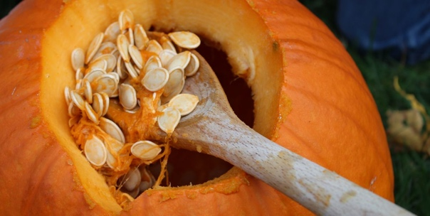

Flower green pumpkin ripe pumpkin
After some time, the vines bees pollinate the flowers My dog Charlie is
begin to flower and they turn into pumpkins eating a ripe pumpkin
from our garden
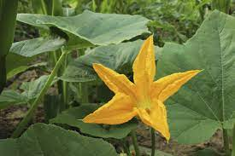
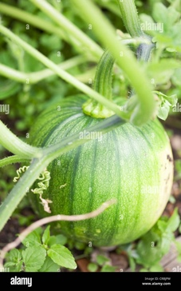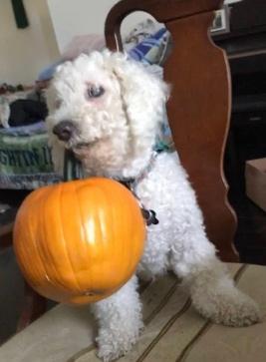

Questions
Write down and answer at least three questions about your plant or animal that you are curious about or you think someone else would ask

Example:
What are some fun facts you learned about pumpkins?
Not all pumpkins are really big when they are ripe, some are small.
Also, I did not know that pumpkins grew out of flowers.
And all pumpkins are green before they are ripe, but they can be different colors when they finish growing such as orange, green, white, and brown
What did you learn about growing pumpkins?
If you don’t make sure the vines extend and have room to grow, they will get knotted and can die.
People can cut open a pumpkin and get the seeds out, but if there are no people, how do pumpkins spread seeds?
Many animals will bite into and eat pumpkins, carrying the seeds to different places they go to.

Rubric
 | 5 points | 4 points | 3 points | 1 point
First Paragraph (Overview) | Fully answers all questions about their plant/animal with at least 3 sentences. | Partially answers all questions about their plant/animal, or some information may be incorrect. | Misses a question about their plant/animal or paragraph is less than 3 sentences. | Does not answer questions about their plant/animal and paragraph is less than 3 sentences.
Second Paragraph (Growth & Maturation) | Fully answers all questions about their plant/animal with at least 3 sentences. | Partially answers all questions about their plant/animal, or some information may be incorrect. | Misses a question about their plant/animal or paragraph is less than 3 sentences. | Does not answer questions about their plant/animal and paragraph is less than 3 sentences.
Third Paragraph (Death & Reproduction) | Fully answers all questions about their plant/animal with at least 3 sentences. | Partially answers all questions about their plant/animal, or some information may be incorrect. | Misses a question about their plant/animal or paragraph is less than 3 sentences. | Does not answer questions about their plant/animal and paragraph is less than 3 sentences.
Photos | All 5 required images with clear titles and descriptions with at least two real photos | All 5 photos some missing title or caption or missing a photo with all having title and caption | Only a few images are present, and titles/captions are missing | Required photos are missing or there are no titles or captions
Questions | Asks and answers 3 interesting questions about their plant/animal | Asks 2 questions about plant/animal, or asks a question having to do with something else | Asks questions about not related to plant/animal, or not serious answers given | Missing questions about their plant/animal.

Total _______/ 25

